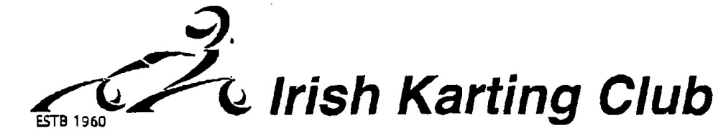

Application for club membership 2020
I hereby apply for membership to the Irish Karting Club and I agree to abide by its rules and regulations
BLOCK CAPITALS PLEASE
NAME_______________________________________________________________
ADDRESS____________________________________________________________
_____________________________________________________________________
_____________________________________________________________________
PHONE NUMBER____________________________________________________
EMAIL______________________________________________________________
RACING CLASS_____________________________________________________
SIGNATURE_______________________________________DATE____________
TYPE OF MEMBERSHIP REQUIRED
- Senior €30
- Junior €20
Mini Kart €10 Novice / Black Plate €10

Cheques/Postal orders should be made payable to: Irish Karting Club. Send this form & membership to LINDA CORMACK 14 CLONSHAUGH CLOSE, DUBLIN 17.
Irish Karting Club Limited. Company registered number 169807

